DOM stands for Document Object Model is an API usually in XML format.

As per W3C specification, one important objective for the Document Object Model is to provide a standard programming interface that can be used in a wide variety of environments and applications. The DOM is designed to be used with any programming language.

When it comes to Appium the Document Object is not like how it will display in Browser as XML. The way it display for mobile app in Appium will be like a hierarchy model.

The Parent Tag <android.widget.FrameLayout> followed by its child tags and super child tags. Again, here Tags are not like XML tags. Tags in Appium represents the class name of the Object/element

Example: Typical browser DOM will be like
<a class="q qs" href="/search?q=Appium+iOS&amp;source=lnms&amp;tbm=vid&amp;sa=X&amp;ved=2ahUKEwi"><span class="HF9Klc iJddsb" style="height:16px;width:16px"><svg focusable="false" viewBox="0 0 24 24" xmlns="http://www.w3.org/2000/svg"><path clip-rule="evenodd" d="M10 16.5l6-4.5-6-4.5v9zM5 20h14a1 1 0 0 0 1-1V5a1 1 0 0 0-1-1H5a1 1 0 0 0-1 1v14a1 1 0 0 0 1 1zm14.5 2H5a3 3 0 0 1-3-3V4.4A2.4 2.4 0 0 1 4.4 2h15.2A2.4 2.4 0 0 1 22 4.4v15.1a2.5 2.5 0 0 1-2.5 2.5z" fill-rule="evenodd"></path></svg></span>Videos
</a>

An Appium way of displaying tags are like,

Dom Structure for iOS

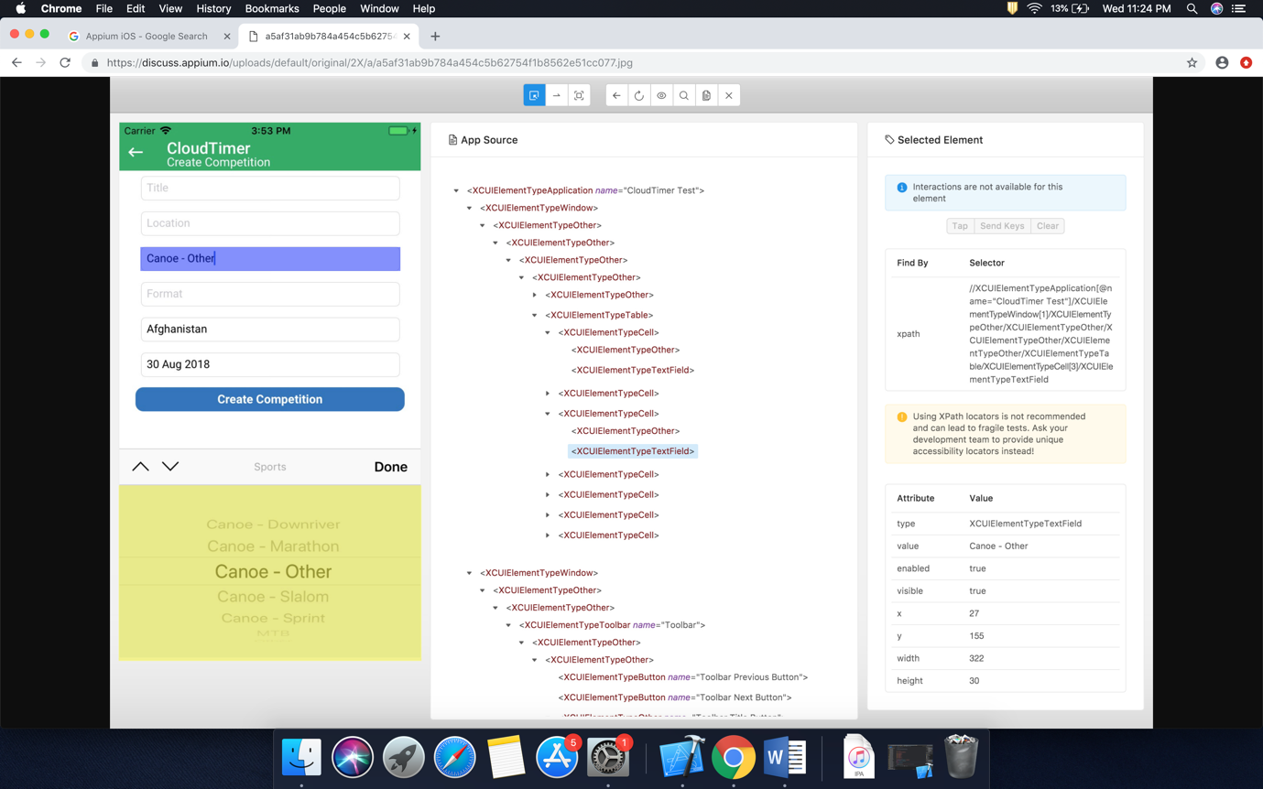

Dom Structure for Android

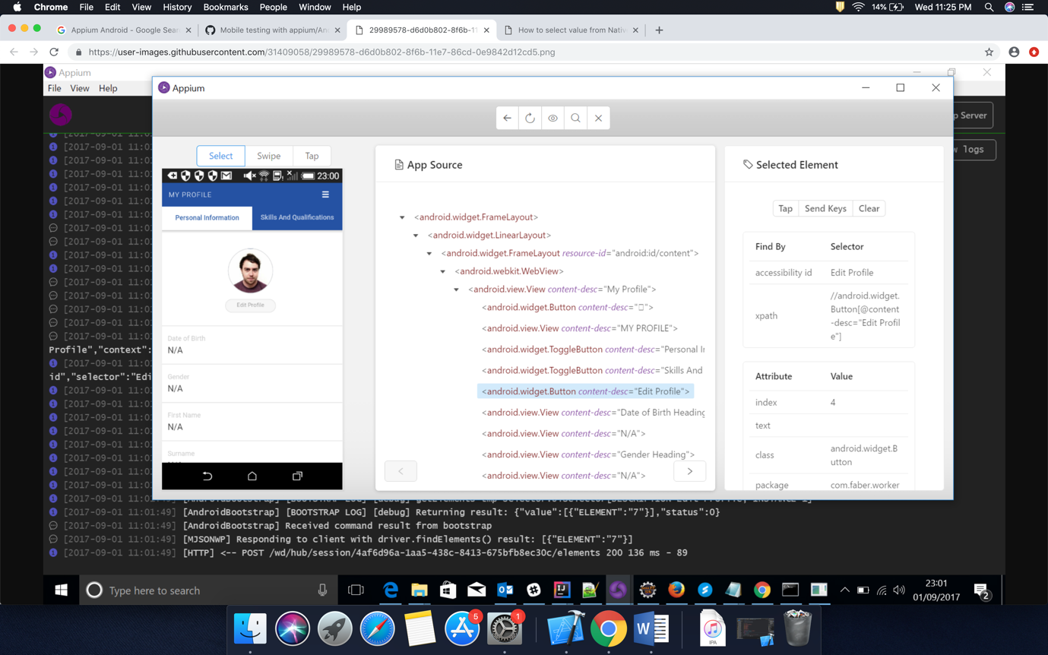

Dom Structure for Web Browser

